Getting started with IT Facilities Guide

Welcome to AIT. This guide is provided to assist new students who have just completed the registration process in AIT with the follow-on actions to get students up and running with their IT facilities. Every student gets a Microsoft Office 365 account which is accessible from any internet connection. This account includes facilities such as student email, OneDrive (online storage) and a facility for students to download a free version of Microsoft Office to personally owned computers or laptops. Students also get an AIT computer account for logging into student computers on campus and a Moodle account.

Moodle is your Virtual Learning Environment where you will access your lecture notes, join remote access your online Zoom classes and submit your assessments etc.

When you register, you will use (or have used) a Registration account (with a username and a PIN (your 6 digit DOB)). This Registration account is separate to your Computer account (& computer account password). See the section on the last page of this document which clearly explains what these two separate accounts are used for.

Description | Page
Logging into your Microsoft Office 365 account (hosting student email and OneDrive) | 1
Logging into your Moodle Account | 3
How to avail of and install your free version of Microsoft Office | 4
How to Use OneDrive | 4
How to change your AIT student password | 5
AIT Computer Account and Registration Account explained | 6

Note: Further instructions on the use of IT facilities in AIT will be provided during Induction.
Logging into your Microsoft Office 365 account (hosting student email and OneDrive)
- Open a web browser
- Browse to https://ait.ie .
- Click on the Quicklinks link close to the top right of the screen (see below (left)), then click on Student Learning Portal.
- The Student Learning Portal has very useful information for all students. This should be the first place that students should go when seeking information on IT resources.
- Click on Access your Microsoft Office 365 Apps here (see below right).

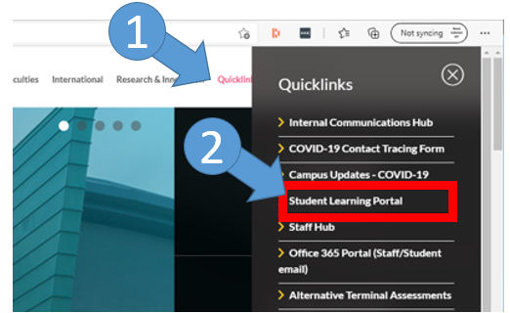 | 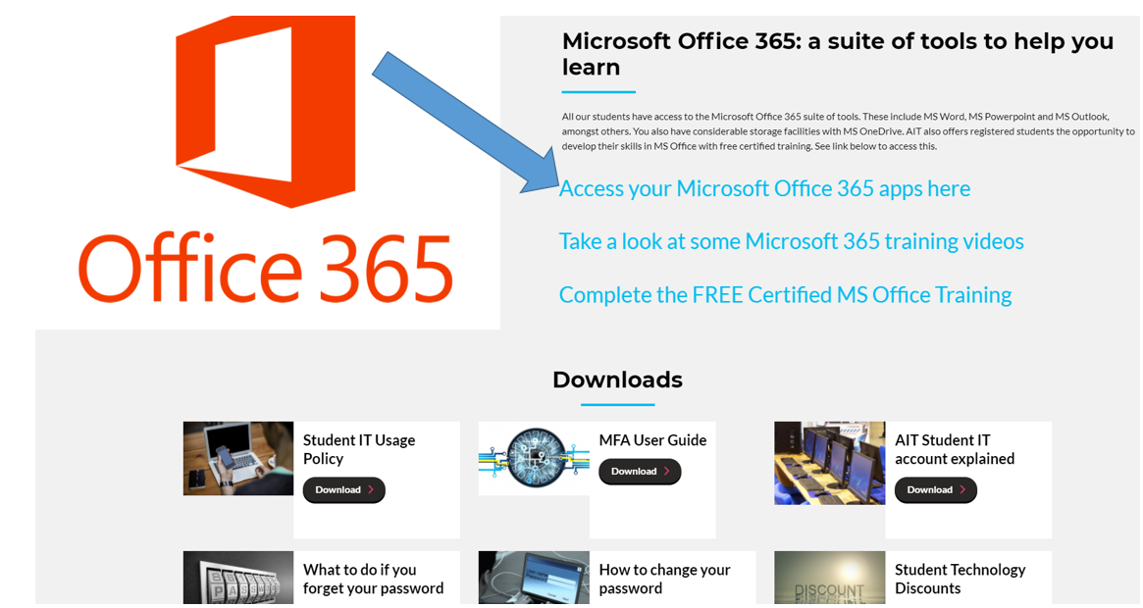

- The page below (left) appears.
- Enter your student username (in the format is a00xxxxxx@student.ait.ie where xxxxxx is your actual student number).
- Click Next. The window below (centre) appears.
- Enter your student computer password and click Sign in.
Your Computer password is (initially set to your 8 digit date of birth (i.e. DD-MM-YYYY), followed by the initial (first letter) of your first name in upper case (i.e. a capital letter) + initial of surname in lowercase. E.g. for a student named Joan Bloggs with a DOB of 14062002, the default password is 14062002Jb
- The window below (right) may appear, if so, click “Don’t show this again” and click Yes.

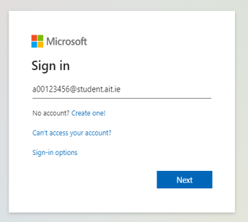 | 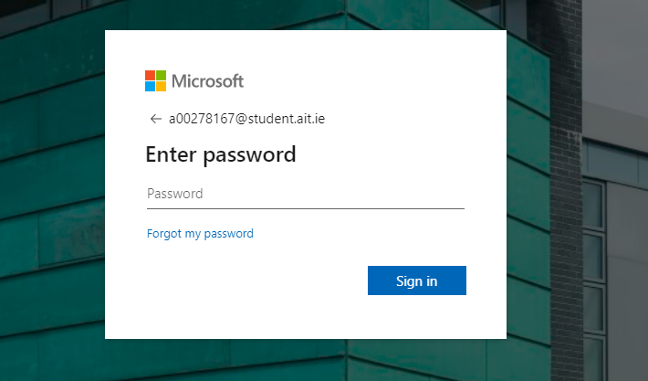 | 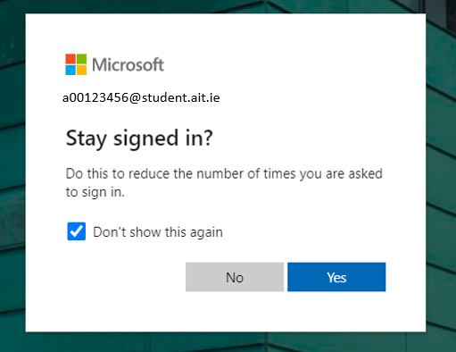

- At this point (or at some point in the near future) you may be required to register for multi-factor authentication (known as MFA). This means you may have to register your mobile phone number with your email account as an additional IT security measure, to be used during subsequent logins.
- You are now logged into Microsoft Office 365. You will see a whole host of applications (apps) that are available to you as a student to use. For accessing your online Zoom classroom and module learning resources, the most important one is Moodle (shown by the yellow arrow below). Note that there may be more than one Moodle link, if so, click on the Moodle with the latest year in it’s title – see further instructions below.

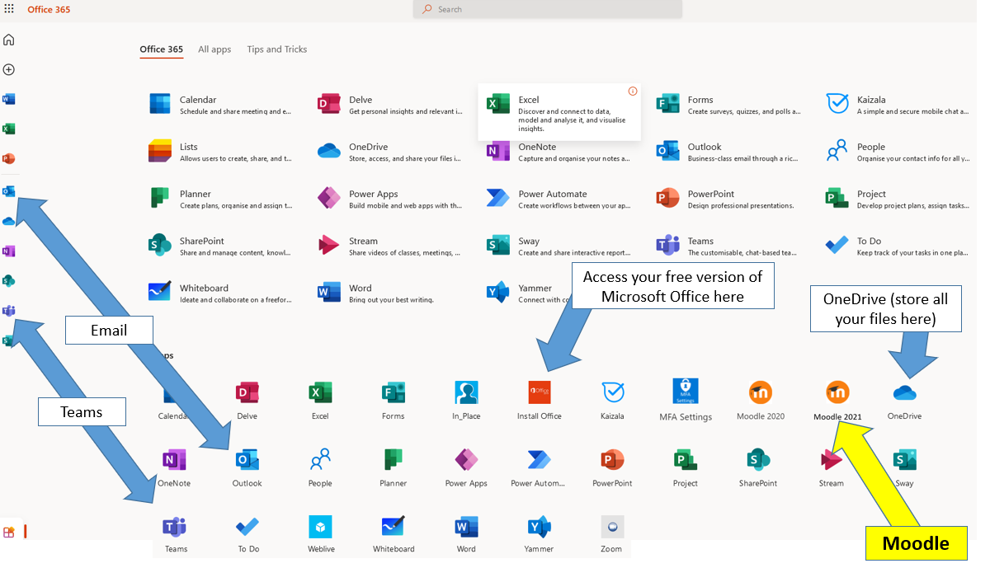

Logging into your Moodle Account (Your Virtual Learning Environment)
Authentication (i.e. entering a username and password) to Moodle is managed by the Microsoft Office 365 authentication process (you completed this process when logging into Office 365 above). Therefore, it is now possible to simply open Moodle from the Office 365 page you have already logged into.
- Click on the Moodle link.
- Click “Open in new tab”.
- The Moodle login page now opens as a new tab in your browser (note the Office 365 page is still open in the first tab, and can be returned to by clicking anywhere within the tab area (shown within the red box below).
- On the Moodle login page, click Login with O365.

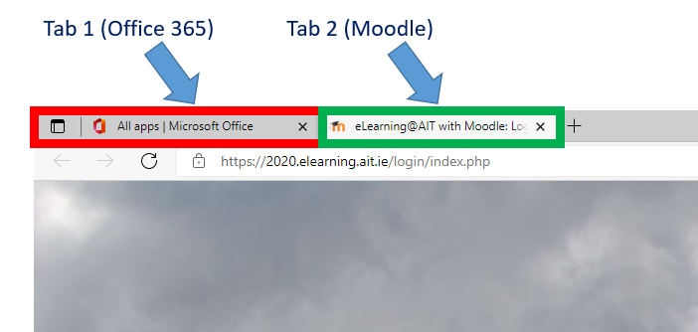 | 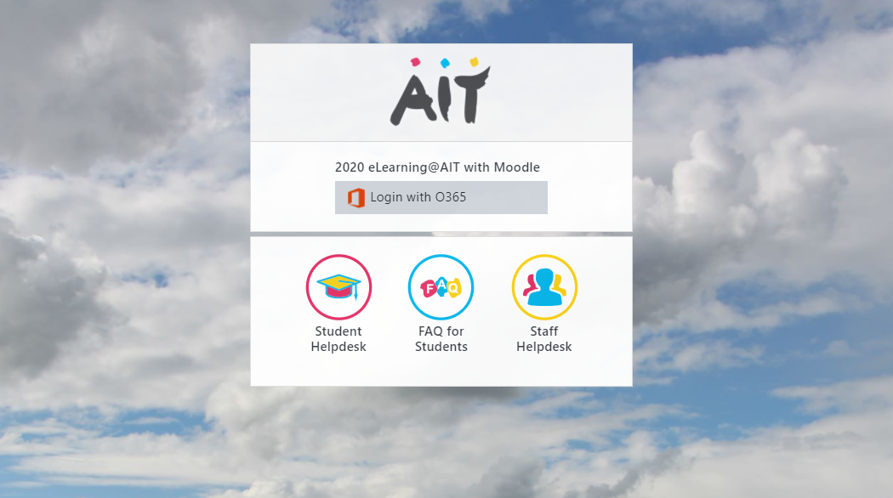

- Because you have already authenticated to Office 365, and because Office 365 manages the Moodle login process, you are automatically logged into Moodle and the Moodle homepage will appear

How to avail of and install your free version of Microsoft Office
AIT Students can download a free version of Microsoft Office (i.e. Word Excel and PowerPoint etc) to their own computer or laptop, via Office 365. See the image on page 2 with an arrow to an app named “Install Office”. Click this link.

How to Use OneDrive

Students should save ALL of their files to OneDrive. Doing so ensures that you will never lose a file as the contents of your OneDrive are always available from any internet connection. Students SHOULD NOT use USB sticks to save files to as these can be easily lost or can pick up viruses when being used on multiple computers.

- Click on OneDrive (from the Office 365 homepage).
- To create a new folder or file, simply click on “New” and choose the type of file or folder you wish to create from the drop down menu.
- Files can also be uploaded using the Upload button.

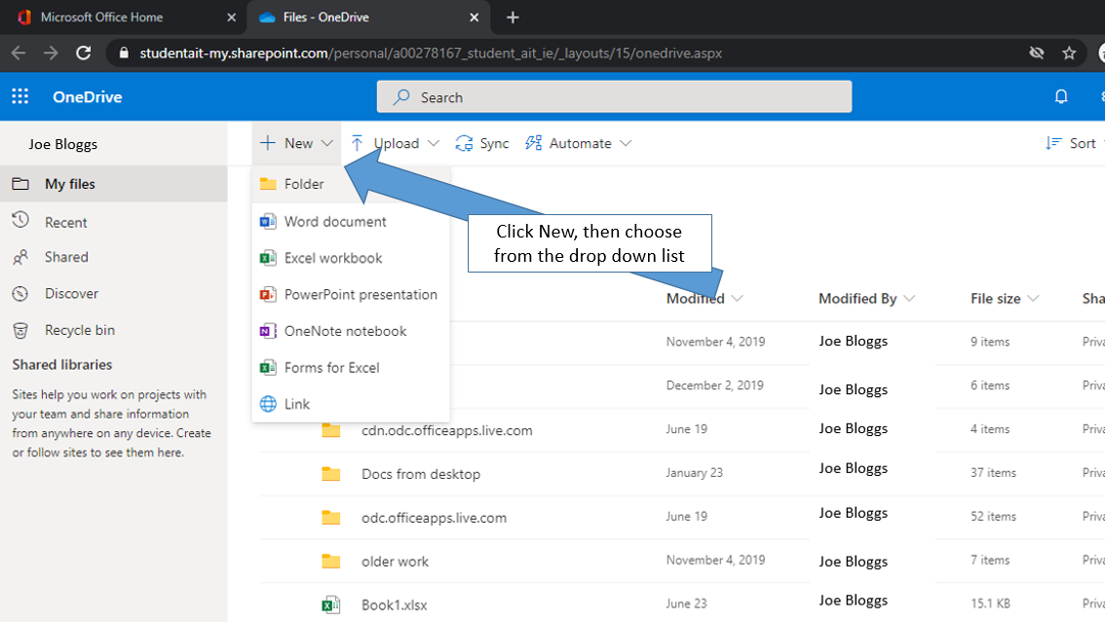

How to change your AIT Student Password
(from the default password of date of birth followed by initial of first name in uppercase, followed by initial of surname in lower case)
- In Office 365 (https://office.com/apps), click the Settings wheel in the top right corner of the screen.
- Click Change your password (as shown below). Follow the instructions.
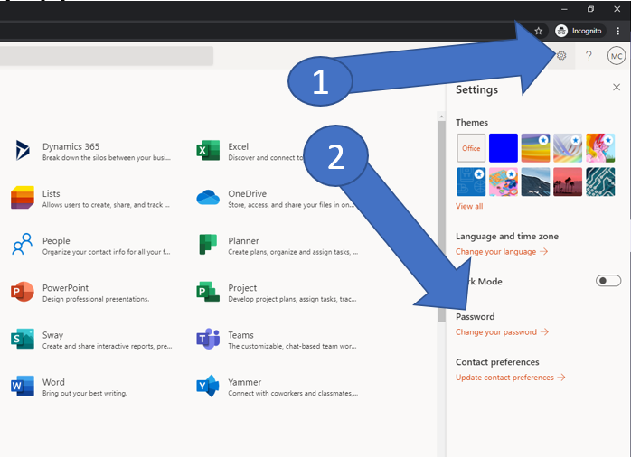 | Passwords will have to conform to these complexity requirements:  - At least 8 characters long  - The password must include at least one character from 3 of these 4 character sets:  - digits (i.e. 1 2 3 4 …)  - Upper case letters (i.e. a capital letter e.g. B)  - Lower case letters (e.g. b)  - Special characters (e.g. ! “ £ $ % ^ & *)

Also note that by changing your password in Office 365, you must now use this same new password when accessing:
  - A computer in AIT b. Wi-Fi in AIT
  - Moodle c. The Library applications

AIT Computer Account and Registration Account explained
In AIT students have 2 separate logins. Both use the same username. Let’s refer to them as a Computer account and a Registration account.

Computer accounts have a password associated with them (initially set to your 8 digit date of birth (i.e. DD-MM-YYYY), followed by the initial (first letter) of your first name in upper case (i.e. a capital letter) + initial of surname in lowercase. E.g. for a student named Joan Bloggs with a DOB of 14062002, the default password is 14062002Jb
Registration accounts have a PIN, initially set to your 6 digit date of birth i.e. DD-MM-YY.
 | Computer Account |  |  | Registration Account
Username Format | A00xxxxxx or A00xxxxxx@student.ait.ie (depending on what application you are accessing (see below)). Example A00123456 |  |  | A00xxxxxx Example A00123456
Used for | Application | Format of Username |  | Used for
 | Office 365 Login | A00xxxxxx@student.ait.ie  (Student email and OneDrive) |  | Use your Registration account to gain access to the “Secure Area” (in the Student Records Management System (Banner)) to access:  - Online registration  - Payment of fees  - Accessing exam results  Login page is: https://ssb.ancheim.ie/ait/app/twbkwbis.P_WWWLogin
 | On Campus Wi-Fi  (known as Eduroam) | A00xxxxxx@student.ait.ie
 | Moodle Login | The Moodle login process is managed by (i.e. is the same as) the Office365 login process.
 | Library Login | A00xxxxxx
 | Virtual Labs  (for some students) | As explained in associated Virtual Lab guides
Password or PIN | ALL OF THE ABOVE APPLICATIONS USE THE SAME PASSWORD i.e. your computer password. You are strongly recommended to change it and to include numbers, letters and symbols. It can be changed on a computer in AIT or online if you have registered for Self service Password reset (details will be emailed to all students). If changed, it automatically changes for all of the above applications. Students with password issues can log a ticket on the Student IT Help Form (link can be found on the bottom of this page https://www.ait.ie/life-at-ait/campus-services/student-learning-portal ) |  |  | Your Registration account uses a PIN (not a password and not related to your computer password). It is initially set to your 6 digit date of birth – students are forced to change this on first login when registering. It can only contain numbers.

