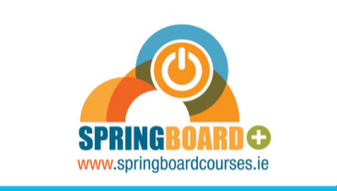

We understand that you really want to know which courses are going to be funded.

However, Springboard+ have not yet released details of which programmes they will be funding for September - we expect this announcement to be made nationally and covered by national media very soon, but it is out of our hands.

Details of all funded courses available at AIT will be available on www.aitflexiblelearning.ie and www.springboardcourses.ie shortly after.

This year, we have applied for a significant number of programmes. As you go through our online prospectus on www.aitflexiblelearning.ie you will see tags that inform you that a programme may be eligible for Springboard+ funding – so if you are interested in the programme – why not register for it now.

All AIT Springboard+ funded programmes listed on these websites after the announcement will include the content, format and timetable to assist you in your decision. If you have any queries after the release of courses, please do contact the Department at 09064 83050 or on Lifelonglearning@ait.ie.

For the time being why not join us at the Virtual Education Expo this Thursday 18th June from 10am to 4pm. This event is free for you to attend, and you can do so on your laptop, tablet or phone. Register to attend for free here - https://www.virtualeducationexpo.ie/

Additionally, AIT will be hosting another Virtual Open Evening on July 9th – And, at that stage we expect to have received the announcement on what programmes are being funded for 2020/2021 under the Springboard + initiative – So why not join us then on www.aitflexiblelearning.ie from 7pm to 9pm. See you then.

